# iOS SDK Access Guide

# 1.SDK Access

1.1 Step One : Import GeeklinkSDK.framework。

Step Two: At Build Phases page, Embed Frameworks option, add GeeklinkSDK.framework into Embed frameworks

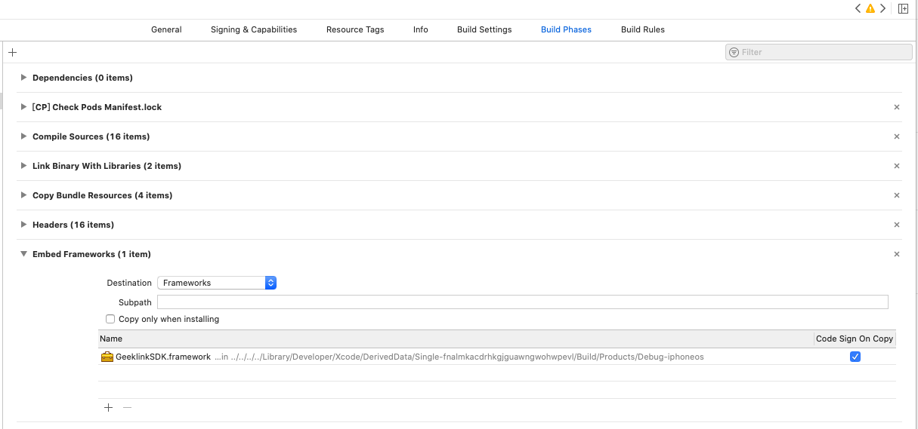

Or add GeeklinkSDK.framework into Frameworks, Libraries, and Embedded Content:



1.2 Other way, add to the Podfile：pod 'GeeklinkSDK'

# 2. Return Example（GLStateType）

|  |  |
| --- | --- |
| StateType.OK | Success |
| StateType.FAILED | Fail |
| StateType.TOKEN_ERROR | Device tokenerror |
| StateType.FULL_ERROR | Data Full |
| StateType.TIMEOUT_ERROR | Timeout |
| StateType.REPEAT_ERROR | Repeat add error |
| StateType.INTERNET_ERROR | Internet error |
| StateType.MD5_ERROR | md5error |
| StateType.NO_CONNECT_ERROR | host offline error |
| StateType.NO_KEY_ERROR | No key error |
| StateType.FILEID_ERROR | Code library device fileI error |

# 3.API

## 3.1 API Initialization Example

+ (instancetype)initManagerWithAppId:(NSString *)appID andSecret: (NSString *)secret;

Interface description：Use for initialization

|  |  |
| --- | --- |
| appId | AppId that you acquire from us. AppID application url: https://api.geeklink.com.cn/OpenSdk |
| secret | Generated key |

## 3.2 Communicate interface

- (void)networkContinue;

Description ： continue communicating with the device, call this functiom when App enters foreground

- (void)stopNetwork;

Description ：call this functiom when App enters background

Purpose：Power saving

## 3.3 Internet configuration interface

- (void)configerWifiWithApBssid:(NSString *) apBssid andApSsid:(NSString *) apSsid andPassword: (NSString *) password configerResult:(void(^)(TopConfigerDevResult * configerDevResult))configerResult;

Description ：Call interface when configure host Internet. Internet configuration of new devic （Do not support 5G Wi-Fi）

- (void)stopConfigureWifi;

Description ：Stop internet configuration

|  |  |  |
| --- | --- | --- |
| apBssid | Router Wi-FiapBssid | |
| apSsid | Router Wi-Fi apSsid | |
| password | Router Wi-Fi password | |
| TopConfigerDevResult Value data from the return result | | |
| state | | GLStateTypeOk｜GLStateTypeFailed | |
| mainType | | Host, refer to device main type description | |
| subType | | Device sub type, refer to device sub type description | |
| token | | Device token | |
| md5 | | Device md5 | |

## 3.4 Connect host device

- (void)linKAllMainDevice:(NSArray *) mainDeviceList

Description ：The protocol is used for link user and host

|  |  |
| --- | --- |
| mainDeviceList | [TopMainDevice] Host List |

## 3.5 Delete host device

- (void)deleteMainDevice:(NSString *)md5 complete:(void(^)(TopResultInfo * resucltInfo))result;

Description ：The protocol is used for deleting host. If want to add the device back. You need to reset the host for network configuration after you delete it.

|  |  |
| --- | --- |
| md5 | Host md5 |
| state | GLStateTypeOk｜GLStateTypeFailed |

## 3.6 Host device upgrade

- (void)upgradeDeviceWithMd5:(NSString *)md5 complete:(void(^)(TopResultInfo * resucltInfo))result;

Description ： Used for upgrading host, it take about 1 minute, don’t cut the host power during upgrade.

|  |  |
| --- | --- |
| md5 | Host md5 |
| TopResultInfo Value data from the return result | |
| md5 |  |
| state | GLStateTypeOk｜GLStateTypeFaile Return success means the device successfully get the upgrade information, it takes about 1 minute to upgrade. |

## 3.7 Get/Set host device’s time zone

- (void)deviceTimezoneWithMd5:(NSString *)md5 action:(GLTimezoneAction)action timezone:(NSInteger)timezone complete:(void(^)(TopGLAPIResult * resucltInfo))result;

- (void)upgradeDeviceWithMd5:(NSString *)md5 complete:(void(^)(TopGLAPIResult * resucltInfo))result;

Description ：Get/Set host device’s time zone。

|  |  |
| --- | --- |
| md5 | Host md5 |
| timezone | time zone * 60. Such as CAST +09:30 = 570 |
| TopGLAPIResult 返回结果有效数据 | |
| md5 |  |
| state | GLStateTypeOk｜GLStateTypeFaile |
| timezone | time zone * 60. Such as UTC+8 = 480 |

# 4 Proxy Method TopGLAPIManagerDelegate

## 4.1 Delegate function for calling interface when Device Status Change Calls.

- (void)deviceStateChange:(TopResultInfo *)resultInfo;

|  |  |
| --- | --- |
| TopResultInfo | |
| md5 | Host md5 |
| subId | 0 means host, Other sub device has their corresponding subId |
| stateValue | Status value of sub devices. |
| mainDevStateInfo | Status of host. |

# 5 Device Type List TopDeviceType

Host Type TopDeviceType

|  |  |
| --- | --- |
| TopNetworkDevice | Internet Connect Device，subType has corresponding TopNetworkDeviceType |
| TopDataBaseDevice | Code library device: subType has corresponding TopDataBaseDeviceType |
| TopCunstomDevice | Custom Device： subType has corresponding CustomType |

Internet Connect Device Type TopNetworkDeviceType

|  |  |
| --- | --- |
| TopNetworkDeviceTypeSmartpi | Smart Pai Device |

Code library device Type TopDataBaseDeviceType

|  |  |
| --- | --- |
| TopDataBaseDeviceTV | TV code library device |
| TopDataBaseDeviceSTB | STB code library device |
| TopDataBaseDeviceIPTV | IPTV code library device |
| TopDataBaseDeviceAC | AC code library device |

# 6 attachme

|  |  |
| --- | --- |
| Smart Devce | Reference《Smart Pi SDK Protocol》 |
| 接入消毒灯设备 | Reference《Disinfection Lamp SDK Protocol》 |

# t